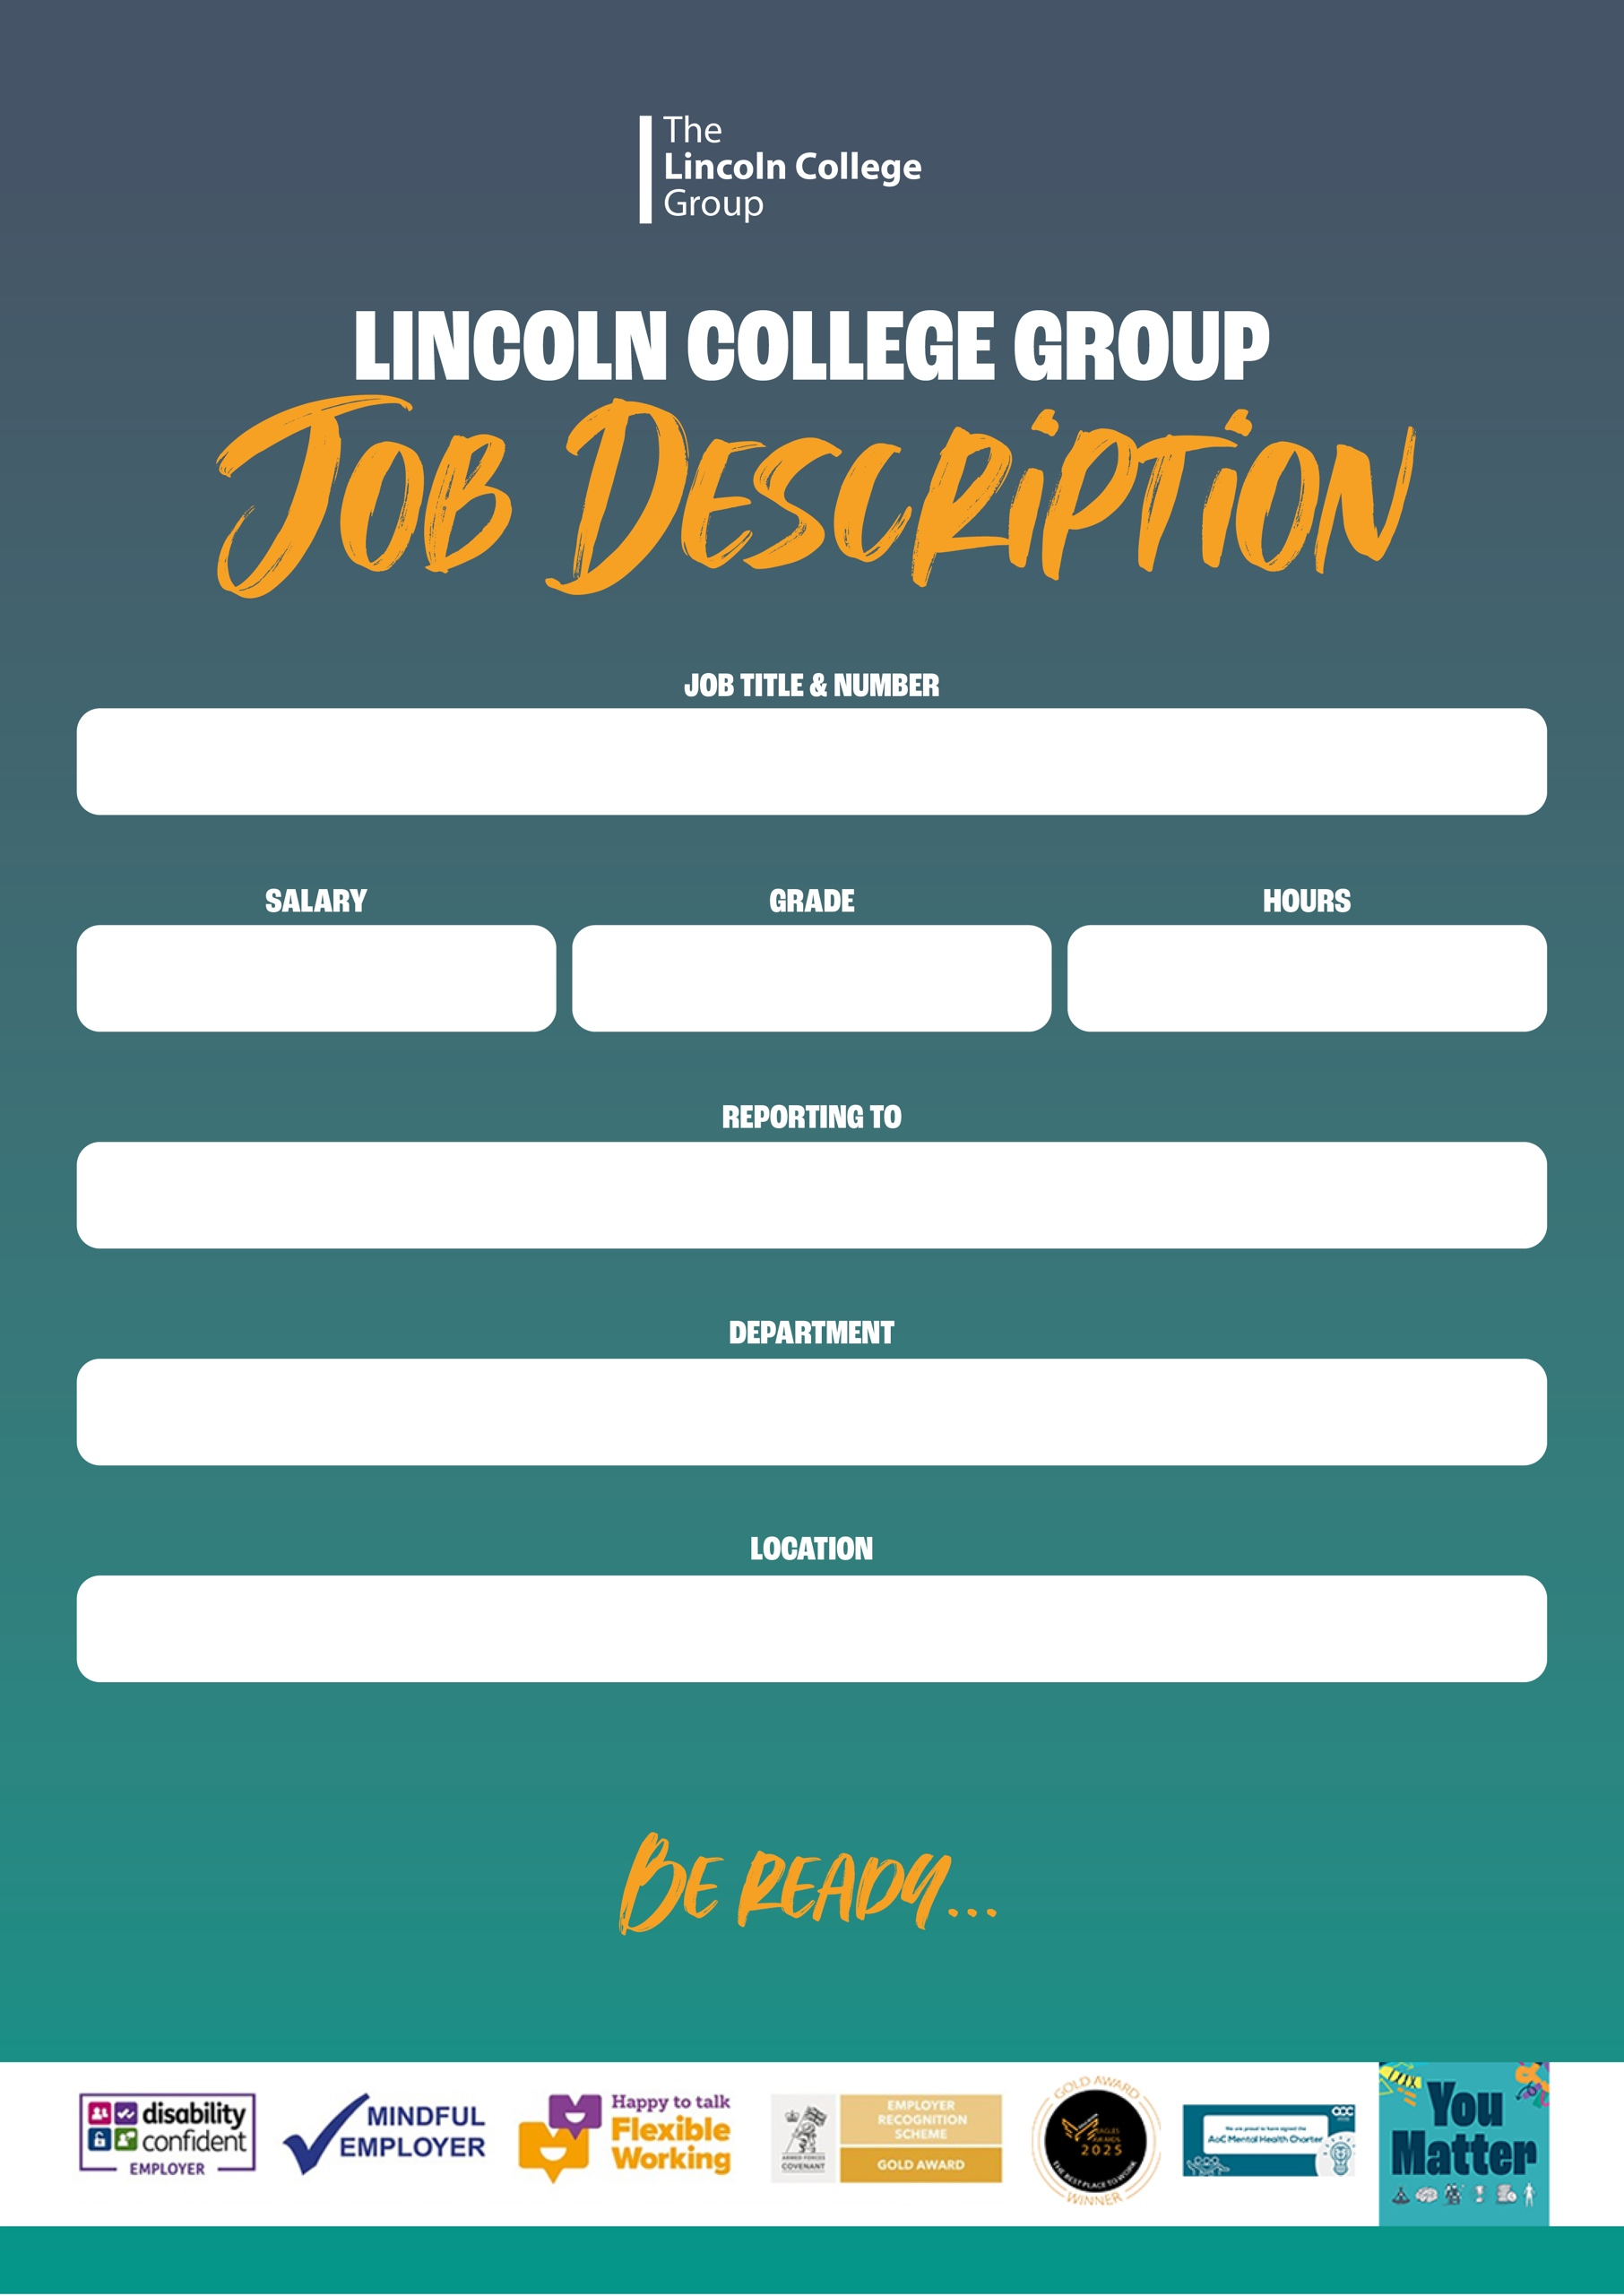

CS1390P: Cleaning Operative

12.5 hours, Term Time Only, 38 weeks per year
CSS Scale 2
£24,853 pro rata per annum

Cleaning Supervisor

Estates & Facilities

Lincoln


Job Purpose:
The work of the postholder is to undertake cleaning of the College Campus.
PRINCIPAL DUTIES AND RESPONSIBILITIES:
- Clean designated area (dusting, sweeping, vacuuming, mopping, cleaning ceiling vents and other tasks set out in cleaning folders) which may be subject to change dependent upon the needs of the College.
- Carry out one off requests and cleaning tasks for open days and special projects.
- Notify management of occurring deficiencies or needs for repairs.
- Ensure cleaning standards are maintained in accordance with the College’s Cleaning Manual.
- To assist the Site Supervisor in organising materials, movement of equipment and stock control.
- Carry out instructions from the Site Supervisor as required.
- To accept responsibility for the implementation of the College’s Equal Opportunities policy throughout all personal contacts in the College and within this area of responsibility.
- To maintain professional standards and expertise by undertaking relevant professional development, including ensuring that knowledge regarding changes to relevant legislation is kept up to date.
- To maintain quality standards appropriate to the post.
- To conform with the Health and Safety requirements relevant to the post.
- To be responsible for the safeguarding and promoting the welfare of children wherever applicable within the role.

N.B. This is not a complete statement of all duties and responsibilities of this post. The postholder may be required to carry out other lawful and reasonable duties as directed by a supervising manager.

 | Knowledge |  |  |  |  | PSM
1 | Knowledge of the existence of COSHH Regulations |  |  |  |  | A/I
 | Skills/Abilities – Interpersonal |  |  |  |  | PSM
2 | The ability to work and clean in a variety of changing environments |  |  |  |  | A/I
3 | The ability to work on one’s own initiative |  |  |  |  | A/I
4 | The ability to contribute and work as part of a team |  |  |  |  | A/I
5 | The ability to communicate effectively |  |  |  |  | A/I
 | Experience |  |  |  |  | PSM
6 | Practical cleaning experience |  |  |  |  | A/I
7 | Recent commercial cleaning experience |  |  |  |  | A/I
 | Work Related Circumstances |  |  |  |  | PSM
8 | Ability and willingness to undertake relevant professional development to maintain up-to-date knowledge of legislation and best practice. |  |  |  |  | A/I
9 | Ability and willingness to work flexibly. |  |  |  |  | A/I
10 | The ability and willingness to undertake relevant staff development |  |  |  |  | A/I
 | Skills/Abilities - Other |  |  |  |  | PSM
11 | Demonstrates a clear commitment to safeguarding and promoting the welfare of children and young people. |  |  |  |  | A/I
12 | Ability to actively promote equality, diversity and inclusion across all aspects of Cleaning Operative. |  |  |  |  | A/I
13 | The ability to learn to use relevant floor cleaning machines |  |  |  |  | A/I
14 | The ability to work and clean in a variety of changing environments |  |  |  |  | A/I
Prepared By: |  |  | Julia Smith – Cleaning Supervisor
Date: |  |  | February 2024
Proposed Selection Method Key (PSM)
A = Application |  |  |  | I = Interview | T = Test

PERSON SPECIFICATION

